The 6th IEEE International Conference on Intelligent Data Acquisition and Advanced Computing Systems: Technology and Applications 15-17 September 2011, Prague, Czech Republic

Photoplethysmography Detection by Smartphone’s Videocamera

Domenico Grimaldi 1, Yuriy Kurylyak 1, Francesco Lamonaca 1, Alfonso Nastro 2

1 Department of Electronics, Computer and System Sciences,

2 Department of Territorial Planning, University of Calabria, Rende – CS, Italy

{grimaldi, kurylyak, flamonaca}@deis.unical.it, [a.nast](mailto:a.nastro@unical.it)[ro@unical.it](mailto:ro@unical.it)

*Abstract***—Smartphone’s video cameras become more and more powerful while the devices itself become used by many people. That allows utilizing them for many every-day tasks. One of such suitable application of the widely used smartphones is monitoring the state of the health. In this paper we propose an approach to detect the photoplethysmograph signal from the fingertip using a smartphone’s camera and built-in LED. The proposed solution allows detecting the proper heart rate and is robust to different situations of wrong-usage of the system.**

***Keywords— photoplethysmography; camera; smartphone; heart rate***

1. INTRODUCTION

Self-monitoring of the vital parameters is very important for timely detection of any health diseases. The blood pressure, heart rate and its change are one of the most important parameters in this case. A recent report

1. shows that patients doing self-monitoring of their vitals were 50 percent more likely to have their blood pressure under control.

The noninvasive way to obtain temporal variation in the blood volume is to use a pulse oximeter (Fig.1a) [2, 3]. A sensor is placed on a thin part of the patient's body, usually a fingertip or earlobe. The light with red and infrared wavelengths is sequentially passed through the subject to a photodetector [4]. The photometric-based plethysmogram (PPG) refers to the monitoring of time varying changes in the intensity of light scattered from tissue in vivo. With the PPG method there are two modes of detection: transmission and reflection [5].

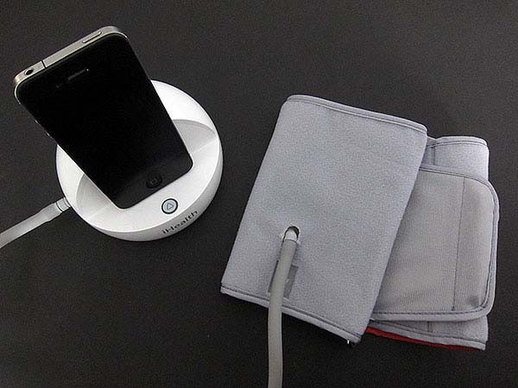

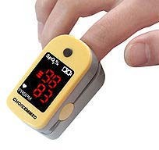

* 1. b)

Figure 1. Example of oximeter (a) and the iHealth Blood Pressure Monitoring System (b).

Such method to monitor the health requires from the patients to buy special equipment and bring it always with them. At the same time, smartphone become one of the most wide and often used devices that the one brings almost everywhere. In addition, the computational power as well as the multifunctional user interface allows their usage in very wide spheres. In particular, they can be used as a part of health monitoring system measuring the vital characteristics. For example, the iHealth Lab Inc. has announced the iHealth Blood Pressure Monitoring System for iPhone, iPod touch and iPad (Fig. 1b) [6]. It consists of a hardware dock, blood pressure arm cuff and software, and allows users to self-monitor their blood pressure at home as well as share results with a doctor.

However, such devices have limitations to the conditions under which they can be used. They are much bigger than the pulse oximeter and cannot be used for continuous monitoring of the blood pressure as require the arterial occlusion.

Most of the recent smartphones are equipped with the high-resolution cameras and LEDs. This is very similar to the construction of the pulse oximeter. So they can be used for express-measurement of the vital characteristics of the heart and the respiratory system.

The idea of this paper is to develop the PPG measurement system for obtaining the pulse rate based on the video, captured from the smartphone’s camera.

In [7] was already proposed to use the smartphone’s camera to detect the PPG. Authors considered only one smartphone’s model (Nokia E63) and reported that the green channel provides a stronger PPG signal than the red one. However, as it will be illustrated in Section II, our tests show that the distribution of the pixels in the green channel is not uniform for different models of the smartphones, like HTC HD2, Iphone4, Nokia, or Samsung. The only channel that has similar characteristics is the red one, while the rest can be used to distinguish a normal usage of the system from the abnormal one, when the finger is not located properly or there is no finger at all.

The rest of the paper is organized as following: the Section II shows the PPG detection scheme, Section III

shows the PPG calculation algorithm, Section IV gives the experimental results while Section V concludes.

1. THE PPG ACQUISITION SCHEME

Taking into account the construction of the smartphone, the reflection model of PPG obtaining was used (Fig. 2).

105

104

103

102

101



a) b)

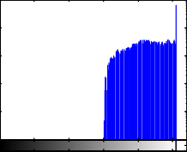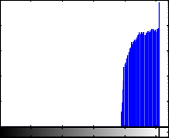105

104

103

102

101

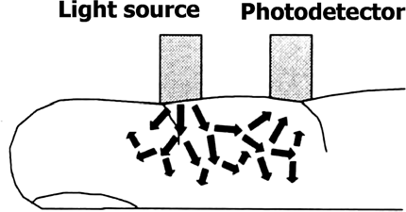Figure 2. The reflection mode for video acquisition [5].

100

0 50 100 150 200 250

100

0 50 100 150 200 250

The scheme for acquiring the PPG signal is depicted in Fig. 3. A subject’s finger should be placed on the smartphone’s camera in the way that it covers both the camera and the LED. The light from the LED passes the finger and the camera fixes the changes in the illumination. The volumetric change of blood in the

104

103

102

101

100

c) d)

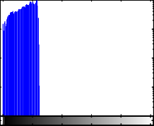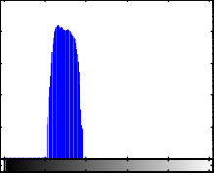105

104

103

102

101

100

finger changes the light absorption and, therefore, can be

0 50 100 150 200 250

0 50 100 150 200 250

used to compute the PPG.

105

104

103

102

101

e) f)

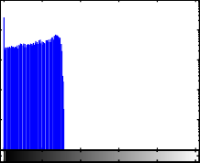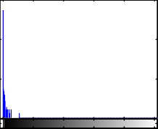106

104

102

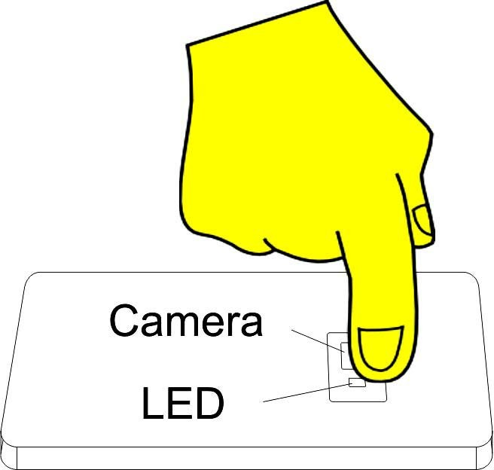100

0 50 100 150 200 250

100

0 50 100 150 200 250

Figure 3. General scheme to acquire video.

One of the problems with self-used health monitoring system is that nobody except the person itself can control the correctness of the procedure. Therefore, the system must detect all the cases of wrong usage (i.e. wrong position of the finger, using the system without placing a finger on the camera, the force with which the finger presses the camera, etc.). Moreover, as it was already mentioned, the frames acquired from different cameras have different color saturation. Fig. 4 shows the difference in two frames as well as histograms of each color channel, obtained from different smartphones.

To distinguish the proper usage of the system we proposed to apply the following scheme for each obtained frame. In particular, each frame is considered as a proper according to:

g) h)

Figure 4. Acquired frames from two different smartphones (a, b) and the histograms for the red (c), green (e) and blue (g) for the first camera and d), f) and h) respectively for the second one.

where *□* is the standard deviation of pixel’s values for each color channel computed for each frame.

Since for the frames with no finger the colors’ distribution in the channels does not concentrate in one part but spreads out to the whole value’s range, the above formula allows selection only the right frames.

1. THE PPG CALCULATION ALGORITHM

To compute the PPG signal we propose to threshold each obtained frame and compute the number of pixels that are bigger than the threshold. There are a few factors that must be taken into account to do that:

1. The different models of the smartphones leads to the different color saturation in video.
2. The different finger’s pressure on the camera, and, therefore, different color ratio.

1, mean(R)-*□*  128 and

1. Finger’s movement in respect to the camera that



*F* (*t*)  





mean(G)  *□*  128 mean(B)  *□*  128

and

 

causes wrong segmentation.

Considering the cases 1) and 2) it is obvious that is not possible to use the fixed threshold value. Therefore, it was proposed the following algorithm to calculate the

⎝0, otherwise

threshold *T*:

1. Compute the average value of minimum and maximum of the red channel during the first 5s. The

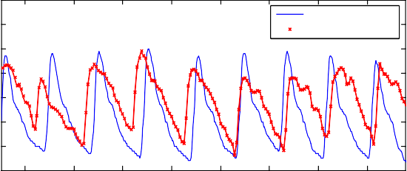90

Oximeter CMS50DL

80 Smartphone HTC HD2

experiments show that for the same video the maximum and the minimum values vary for about 5 levels of the range [0, 255]. Thus, the threshold value to detect a PPG is established as 95% of the range between min and max values during the first 5s as

*T*  max(*I* )  1 (max(*I* )  min(*I* ))  

20

70

60

PPG value

50

40

30

20 14 15 16 17 18 19 20 21

Time [s]

1. For each new frame compute the number of pixels that are bigger than the thereshold *T*:

Figure 6. Acquired photoplethysmogram from oximeter (blue) and smartphone (red).

To prove the suitability and the correctness of the proposed method the above test was repeated again after

*PPG*(*i*)  *I* ,

*I*  *T*  

squatting for 60s. As it can be seen from Fig. 7, the heart rate frequency detected on the smartphone corresponds to

The problem 3) was overcome by computing the center of the area that belongs to the pulsations. When the center or the ratio between its width and height changes, the computation should be restarted.

The obtained signal is generally referred to the inverted PPG (Fig. 5) [5]. In [8] was found that the inverted PPG is a local phenomenon restricted to the reflection mode. It is thought to be caused by a relative increase in the optical density of the surrounding tissue in

the one from oximeter.

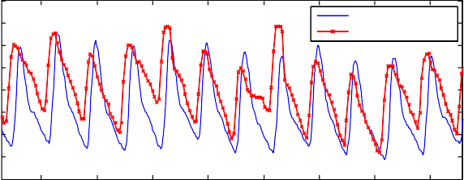90

80

70

60

PPG value

50

40

30

20

Oximeter CMS50DL Smartphone HTC HD2

relation to the arterial vessels.

10 54 55 56 57 58 59 60 61

Time [s]

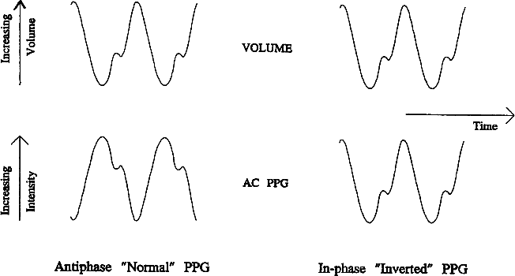

Figure 5. "Normal" and "inverted" AC PPG signals [5].

Thus, the final PPG signal is inverted to be used for further processing.

1. EXPERIMENTAL RESULTS

For the experimental tests we used different models of smartphones such as HTC HD2, iPhone4, Samsung Galaxy SII and the Finger Pulse Oximeter SPO2 Monitor CMS50DL. To compute the PPG and compare it with the one obtained from the oximeter, video was recorded on the smartphone and then transferred to the computer. The signals were obtained simultaneously by smartphone and oximeter using two fingers on the same hand. Further processing was done in Visual Studio C++ using the OpenCV library.

In Fig. 6 is reported the PPG signal acquired in the normal subject’s state.

Figure 7. Acquired photoplethysmogram from oximeter (blue) and smartphone (red) after squatting for 60s.

1. CONCLUSIONS

This paper is devoted to measure the photoplethysmography with a smartphone’s videocamera. It was showed that only the red channel has similar characteristics for different models of the smartphones while the green and blue may vary dramatically. However, such information can be used to filter the wrong usage of the system, i.e. when the finger was not places correctly. The experimental results confirm the correctness and suitability of the proposed technique in respect to the oximeter.

REFERENCES

1. A. Smith, T. Ferriss, “Home health monitoring may significantly improve blood pressure control,” *Kaiser Permanente Study Finds*, <http://xnet.kp.org/newscenter/pressreleases/co/2010/052110telehea> lthstudy.html, May 21, 2010.
2. A. Reisner, P. Shaltis, D. McCombie, H. Asada, “Utility of the Photoplethysmogram in Circulatory Monitoring,” *Anesthesiology*, vol.108, issue 5, May 2008, pp 950-958.
3. P. Leonard, N. Grubb, P. Addison, D. Clifton, J. Watson, “An algorithm for the detection of individual breaths from the pulse oximeter waveform,” *Journal of Clinical Monitoring and Computing*, vol 18, 2004, pp.309–312.
4. S. Linder, S. Wendelken, E. Wei, S. McGrath, “Using the Morphology of Photoplethysmogram Peaks to Detect Changes in Posture,” *Journal of Clinical Monitoring and Computing*, vol. 20, No. 3, 2006, pp. 151-158.
5. D. Damianou, “The wavelength dependence of the photoplethysmogram and its implication to pulse oximetry,” *thesis for the degree of Doctor of Philosophy*, University of Nottingham, October, 1995.
6. *Blood Pressure Readings with iPhone and iPad*, <http://www.blood-pressure-monitoring.org/blog/iphone-ipad-> blood-pressure-readings/, January 2011.
7. E. Jonathan, M. Leahy, “Investigating a smartphone imaging unit for photoplethysmography,” *Physiological Measurement*, vol. 31, no.11, pp. N79-N83(5), November 2010
8. J. Nijboer, J. Dorlas, H. Mahieu, “Photoelectric plethysmography: some fundamental aspects of the reflection and transmission method,” *Clin Phys Physiol Meas,* vol. 2, No. 3, 1981, pp. 205- 215.